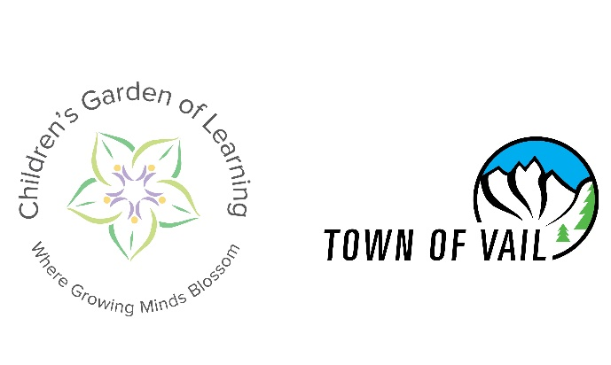

Children’s Garden of Learning | 330 S. Frontage Rd., Lionshead
Ribbon Cutting Ceremony | November 2, 2021
Architect: Pierce Austin Architects
General Contractor: MW Golden Constructors & Palomar Modular Buildings
Operator: Children’s Garden of Learning
Owner: Town of Vail
Cost: $3 million

About the Project
The new Children’s Garden of Learning facility features 4,800 sq. ft. of space, including 5 classrooms, 6 restrooms, kitchen, 2 offices, 2 flex spaces and 4,500 sq. ft. of outdoor play area. The building includes floor to ceiling windows offering direct sunlight and dramatic views. The new location provides convenient access to explore nature along the recreation path, attend story hour at the Vail Public Library, take a field trip by boarding a Town of Vail bus, gondola, or by foot. Future features include creation of a nature nook on the grounds which will offer an open space for children to explore nature.
The facility is licensed for 61 students by the State of Colorado Department as of Oct.16, 2021, and began serving students on Oct. 18, 2021. The building features use of 5 specially designed modular structures built by Palomar Modular Buildings to meet the needs of the preschool. The town worked closely with the Children’s Garden of Learning Board of Directors and staff to ensure the school’s operational needs were incorporated in the design.
Project Coordination
Town of Vail staff, headed by Town Engineer Tom Kassmel, worked closely with Children’s Garden of Learning to provide a seamless transition from the former location at 129 N. Frontage Rd. W. to the new location in Lionshead, formerly used as the charter bus lot. Opening of the preschool in its new location on Oct. 18, 2021, has cleared the way for construction of The Residences at Main Vail which will be completed in summer 2023. Key construction milestones during the preschool project included:
- Request for Proposal issued for modular manufacturer - October 2, 2020
- Town of Vail PEC Design Approval - January 11, 2021
- Modular Building Contract Awarded - January 19, 2021
- Town of Vail Design Review Board Approval by Appeal - February 16, 2021
- Construction Contract Awarded - May 4, 2021
- Start of Construction - June 1, 2021
- Modular units set - July 29, 2021
- Substantial Completion - October 15, 2021

Children’s Garden of Learning has a lease with the Town of Vail to operate at the new site for $10 per year for the next five years. The temporary location will allow time to identify a permanent home for the school while planning for implementation of the first phase of the Civic Area Plan takes place which will repurpose the property.
About Children’s Garden of Learning
Children’s Garden of Learning is a Reggio Emilia-inspired preschool. With 25 years of rich history in educating young children and a highly educated and qualified staff, CGL is one of Vail’s greatest assets. Inspired by the Reggio Emilia philosophy, Children’s Garden of Learning partners with children, families, and the Vail Valley community to provide an inquiry-based education for young learners. Teachers and children co-construct their learning experience through observation, intentional planning, creative environments, and active exploration of materials. Our goal is for each student to emerge as socially capable, creative citizens who love learning.
Each year, CGL averages 80 students ranging in age from 18 months old to 5 years old. The two toddler rooms are limited to 7 students each day to allow for increased individual attention in these busy, exciting growth years. Toddler rooms serve children ages 18 months to 3 years old. Both preschool rooms are limited to 14-15 students each day and staffed with 2 teachers per room. The three preschool rooms serve students from age 3 to 5.
History of Children’s Garden of Learning
Two well-known Vail preschools, the Learning Tree and the ABC School, were opened in 1986. With a long history of providing wonderful preschool education for Vail’s children, these two schools merged and became the Children’s Garden of Learning in 2002.
At that time, CGL incorporated as a not-for-profit 501c3 and was temporarily housed at Red Sandstone Elementary while its former home was being built as part of the Middle Creek Village Apartments development.
www.childrensgarden-vail.com
Relocation of Oversize Vehicle Parking
Oversize vehicle parking for trailers, RVs and charter buses has been relocated to the North Frontage Road west of the West Vail Fire Station for free day parking from 7 a.m. to 11 p.m. as well as paid overnight parking during ski season. There is a three-day maximum stay per 30 days in this area. Additional oversize vehicle parking is available on a first-come, first-served basis on the North Frontage road across from the West Vail Mall from 7 a.m. to 11 p.m. Overnight parking is prohibited across from the West Vail Mall.

