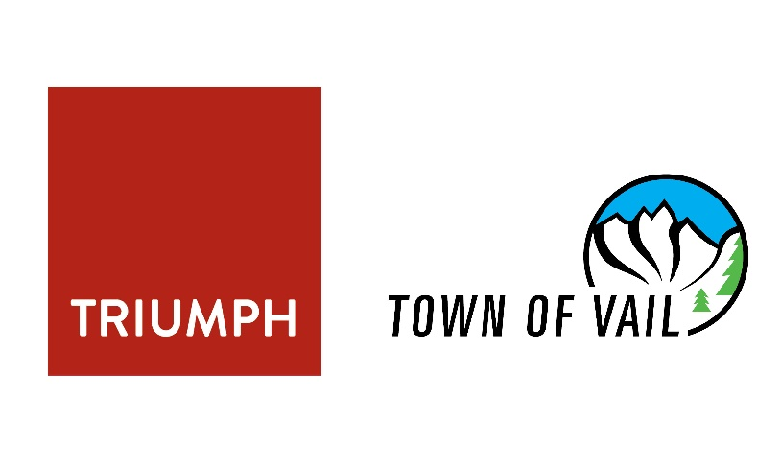
Residences at Main Vail | 129 N. Frontage Rd. W.
Groundbreaking Ceremony | November 2, 2021
Architect: 359 Design/Triumph West
General Contractor: Triumph Development West, LLC
Owner: Town of Vail
Estimated Completion: Summer 2023
Estimated Cost: $26 million

About the Development
The Vail Town Council is celebrating the culmination of more than two years of planning and coordination to make way for construction of Vail’s largest housing development. The Residences at Main Vail will advance the Town of Vail Housing goal of acquiring 1,000 additional deed restrictions by the year 2027. Not since construction of the Chamonix Vail Townhomes and Vail Commons has such an impact been made in increasing the number of available homes for working residents.
The Residences at Main Vail have been designed as a 100% deed-restricted, for rent, residential development to include a mix of 72 one- and two-bedroom apartments containing at least 72 parking spaces onsite with additional means of meeting the transportation needs of the new residents
Additional amenities include individual storage unit lockers, on-site laundry, indoor and outdoor community gathering spaces, a solar panel installation for on-site energy production with 100% electrification systems to minimize the carbon footprint of the new building.
The central location near the Vail Town Center roundabout provides convenient pedestrian access to Vail Village and Lionshead Village and will be home to as many as 200 year-round and seasonal Vail residents.
The new homes will be available for occupancy by persons and families who are employed a minimum of 30 hours per week, on average on an annual basis, at a business located within Eagle County. It is most likely, however, that leasing preference will be granted to those persons employed at businesses within the Town of Vail.
Construction Timeline
Construction will take place in two phases with completion anticipated by summer of 2023.
Phase 1 construction – November 2021 - March 2022
Includes demolition, excavation and construction of both permanent and temporary shoring walls over the winter season.
Phase 2 construction – March 2022 - June 2023
Includes site grading, utilities, vertical building improvements and landscaping.
Financing
Because of historically low interest rates in municipal financing and the ability to retain ownership of the property in perpetuity, the town has arranged to finance construction of the Residences at Main Vail via tax-exempt certificates of participation. Bonds were sold on October 20, 2021 providing $25 million to the project. As a part of the financing process, the town’s bond rating was evaluated and ultimately upgraded to Aaa, allowing the town to receive the best interest rate possible on the financing. Future rental income will cover the annual debt payments of $1.2 million. The 30-year repayment will be complete in 2051, with total interest cost of $14.3 million (2.7% interest rate).
About the Property
The Town of Vail acquired the property, known as Lot 3 Middle Creek, as part of the larger Mountain Bell site in 1974. In 2004 an early childhood center was constructed on the property as a condition of approval during construction of the $20 million Middle Creek Village Apartments, also located on town property. The development was financed through private equity, LIHTC tax credits, Colorado Housing & Finance Authority and HUD loans. The 4,500 sq. ft. Children’s Garden of Learning, with three classrooms and space for 58 early childhood education students, opened in 2005 with completion of the Middle Creek homes. To make way for The Residences at Main Vail, the Lot 3 Middle Creek parcel was created by resubdivision in July 2020, in partnership with Coughlin & Company, the leaseholder and owner of the Middle Creek Village Apartments. In addition, the Town of Vail and Board of the Children’s Garden of Learning worked together to relocate the preschool to a temporary facility in Lionshead with 100% of the $3 million construction funded by the town. The new school opened on Oct.18, 2021, and will remain in its new location for up to five years, per a lease agreement between the town and Children’s Garden of Learning. This temporary location will allow time to identify a permanent home for the school.
Role of Triumph Development West
The role of Triumph Development West has evolved from a leasehold interest developer that would have owned and operated improvements on the property to a fee-based developer with a property manager role to be executed by a future management agreement. The decision points include the following:
- Feb. 2, 2021: Vail Town Council passed Resolution No. 3, Series of 2021, approving a Pre-Development Agreement for the Middle Creek Project. At this time the agreement was structured as a public-private partnership with Triumph Development where the town would retain ownership of the land and Triumph would construct, own and operate the new housing project. Under this agreement Triumph was to be paid a $300,000 management fee and up to $390,000 for design and development consultants to manage the entitlement process. To date, all but $100,000 in milestone payments have been paid.
- March 2, 2021: Vail Town Council passed Resolution No. 10, Series of 2021, approving a Development Agreement for the Middle Creek Project. This agreement set forth intentions for a future ground lease and to move forward with plans for construction of the Residences at Main Vail. The agreement was intended to be a public-private partnership. However, during negotiations with Triumph concerns about the high cost of financing in the private sector led the town’s internal project committee to consider town-initiated financing to take Town of Vail advantage of record low interest rates available to municipalities and the town’s financial strength.
- June 15, 2021: Vail Town Council directed Town of Vail to finance the construction of the Residences of Main Vail and that the Town of Vail would retain ownership of the Residences of Main Vail. This was a change in the original structure of a public private partnership to a fee-based development and included an availability fee of $3.5 million to be paid to Triumph in two milestones ($1.5 million at building permit and $2 million at certificate of occupancy).
- Aug. 17, 2021: Vail Town Council approved a Professional Service Agreement for up to $608,000 to continue work on the design, planning and entitlement process while the larger development agreement was being negotiated.
- Sept. 21, 2021: Vail Town Council passed Ordinance 18 of 2021 authorizing the sale of up to $25 million in Certificates of Participation to finance a majority of the project. Closing took place October 20, 2021.
- Oct. 19, 2021: Vail Town Council passed Resolution No. 43, Series of 2021 approving a development agreement with Triumph Development West LLC for Phase 1 Residences at Main Vail.
To date, Triumph Development has managed the entitlement process for the project under the Pre-Development agreement, Development Agreement and Professional Services Agreement, and the Town and Triumph as co-applicants, have filed all necessary development applications for the project. The town continues to have sole ownership rights to all application materials and approved development plans.

